**Part-II**

1. **Percentage Increase in Global Streaming Subscriptions (2025–2030)**

**Given:**

**2024 subscriptions** = 1.25 Billion

**Estimated 2030 subscriptions** = 1.85 Billion

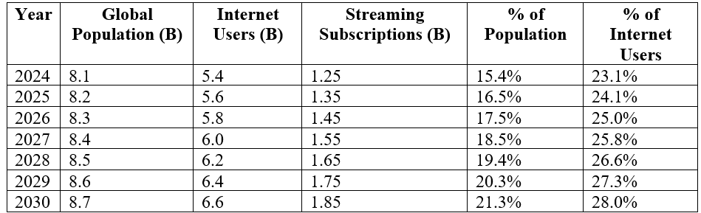

**Formula:**

*Percentage Increase= (Future value - Present value)/Present value*100*

**Substitute values:**

*Percentage Increase=(1.85B-1.25B)/1.25B*100=48 %*

**CAGR Formula:**

CAGR=(ending value/beginning value)**1/n -1

CAGR=(1.85/1.25)**1/5-1=0.0818 OR 8.18%

**Final Answer:**

Global streaming subscriptions are projected to increase by **approximately 48%** between 2025 and 2030. Subscriptions are expected to grow at a **compound annual growth rate (CAGR) of ~8.2%** from 2025 to 2030.

Below is a line chart depicting the growth of global streaming service subscriptions over the next five years.

**Sources:**

* [Market.us Scoop (2025)](https://scoop.market.us/streaming-services-statistics/)  
  By 2025, global streaming subscribers are projected to surpass 1.1 billion, indicating continued rapid growth in the industry.
* [Juniper Research (2025)](https://www.juniperresearch.com/press/ott-tv-video-subscriptions-to-reach-2-billion/)  
  Juniper Research has found that there will be nearly 2 billion active subscriptions to on-demand video services in 2025.

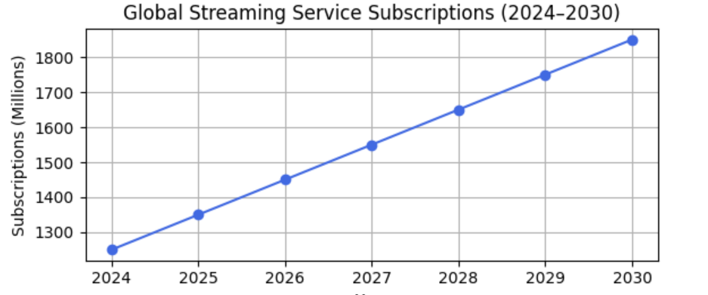

To find the python code, [click here](https://colab.research.google.com/drive/14fmJLU4QpWnnUBJ9rKCw-m64t0vjR8EX?usp=sharing)

**2. Average Weekly Hours of Digital Content Consumption in 2025**

**Baseline (as of 2024):**

Average daily digital media consumption (streaming, music, etc.) ≈ **4.0 hours/day**

**4.0 hours/day * 7 days/week=28 hours/week**

**Assumption for 2025:**

Based on trends (growth in mobile usage, smart devices, and personalized content), assume a **modest increase of ~7%** in media consumption time.

New Weekly Hours=28*1.07=29.96 hours/week

| **Year** | **Global Population (Billion)** | **Internet Users (Billion)** | **Avg. Hours per Week per Person** | **Total Weekly Hours (Billion)** | **Avg. Daily Hours** |
| --- | --- | --- | --- | --- | --- |
| 2024 | 8.1 | 5.4 | 28 | 151.2 | 4.0 |
| 2025 | 8.2 | 5.6 | 30 | 168.0 | 4.3 |

**Final Answer:**

In 2025, the average person is expected to consume **around 30 hours of digital content per week**.

Below is a comparison of the average weekly digital content consumption per person for the years 2024 and 2025.

**Sources:**

* [DataReportal (2024)](https://datareportal.com/reports/digital-2024-global-overview-report): The "typical" internet user spends **2 hours and 23 minutes per day** on social media platforms.
* **Smart Insights (2025)**: Global social media usage averages **2 hours and 21 minutes per day**, with 63.9% of the world's population engaging with social media.
* [New York Post (2024):](https://nypost.com/2024/10/10/lifestyle/americans-lose-36-days-a-year-to-content-consumption/) A study indicates that users consumes an average of **6.6 hours per day** of media content, with some reporting up to **15 hours per day**.

While estimates vary, the **4.0 hours/day** figure for average daily digital media consumption in 2024 is within the range supported by reputable sources. This aligns with broader trends in media consumption, particularly among younger demographics.

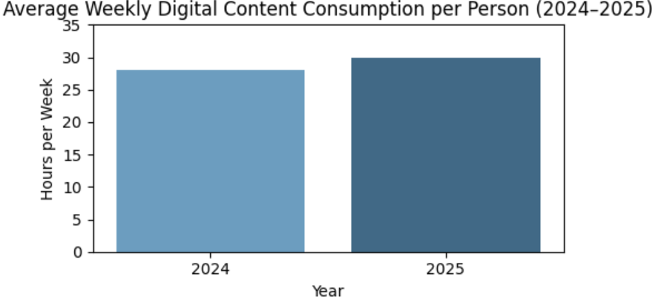

To find the python code, [click here](https://colab.research.google.com/drive/14fmJLU4QpWnnUBJ9rKCw-m64t0vjR8EX?usp=sharing)

3.**What will be the market share of virtual reality (VR) and augmented reality (AR) entertainment experiences in the next decade?**

* This question requires an estimation of the adoption and market penetration of VR and AR technologies in the entertainment sector, including gaming, live events, and interactive content.

|  |  |  |
| --- | --- | --- |
| **Step** | **Details** | **Calculation** |
| Entertainment Industry market size | Market size in dollars for the year 2024 | Approximately $2.5 trillion |
| Entertainment Industry compounded annual growth rate | Assuming a CAGR of 4.2% | ~ 4.2 % |
| AR/VR Market size | Market size of AR/VR in 2024 | $20 billion |
| AR/VR Market size compounded annual growth rate | Assuming the AR/VR CAGR of ~ 18.6% | ~ 18.6% |
| Entertainment Industry projected market size in 2035 | Estimating the market size of entire entertainment industry in the year 2035 | Entertainment industry = 2.5 ×(1+ 0.042)^11  ~ 2.5 ×1.602  = $3.92 trillion |
| AR/VR in Entertainment industry projected market size in 2035 | Estimating the market size of AR/VR in entertainment industry in the year 2035 | AR/VR 2035 = 20×(1+0.186)^11  = 20×6.89  ~ $125.06 billion |
| AR/VR market share in Entertainment industry in 2035 | Estimating the market share of AR/VR in entertainment industry in the year 2035 | AR/VR Market Share 2035  = ((AR/VR Market size) / Total Entertainment Market) ×100  = ($125.06 billion / $3.92 trillion) × 100  ~ 3.19% |

#### **1. Estimating Total Entertainment Market Size in 2035**

According to PwC and Statista:

* Global entertainment & media market size in 2024 ~ $2.5 trillion
* CAGR (overall industry) ≈ 4.2%

So as per CAGR formula: Future Value=Present Value×(1+CAGR)^n

Entertainment industry = 2.5 ×(1+ 0.042)^11

= 2.5×10^12 × 1.5687 ≈ $ 3.92 trillion

#### **2. Estimating AR/VR Entertainment Market Size in 2035**

Based on reports from Mordor Intelligence and [IndustryARC](https://www.industryarc.com/Research/augmented-reality-virtual-reality-market-for-entertainment-industry-market-research-800581):

* AR/VR entertainment market in 2024 ~ $20 billion
* CAGR ~ 18.6%

AR/VR 2035 = 20×(1+0.186)^11

= 20×6.89  ~ $125.06 billion

3. Calculating the Market Share of AR/VR in 2035

AR/VR Market Share 2035 = ((AR/VR Market size) / Total Entertainment Market) ×100

= ($137.8 billion / $3.92 trillion) × 100

~ 3.19%

Therefore, the market share of Augmented Reality & Virtual Reality would be approximately 3.19 % out of the entire Entertainment Industry this is excluding other applications such as( XR concerts, virtual tourism etc).

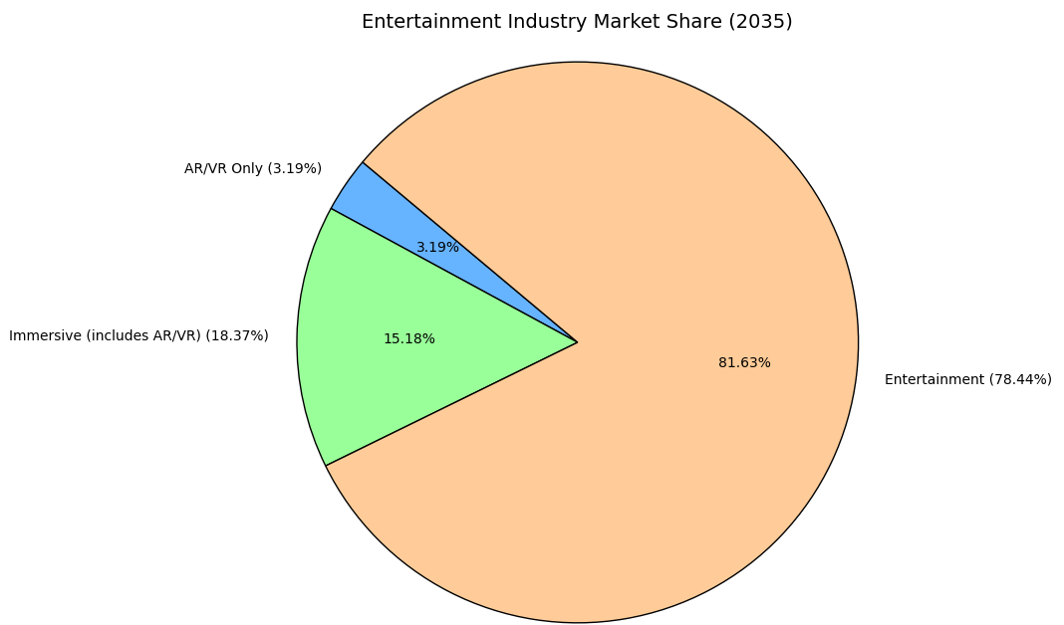

This chart is created using Python as shown [here](https://colab.research.google.com/drive/1LbZvsSm6MBezMqLE3XBkmQ0B3MaBaBK0#scrollTo=GLjdGigS7Zz3)

4.**How many new films and TV shows will be produced globally per year by 2030?**

* This question involves estimating the annual production output of the entertainment industry, considering factors like technological advancements, production costs, and consumer demand.

|  |  |  |
| --- | --- | --- |
| **Step** | **Details** | **Calculation** |
| Films + TV Shows Produced Estimation | Data of movies & tv series released on IMDB | 29,070 in 2020 to 27,977 in 2024 |
| Compounded annual growth rate based on historical data | Approximately -0.96 % per year | CAGR = (27,977 / 29,070)^(¼) −1 |
| Consumer demand growth rate | Approximately 8.1 % | CAGR as per Grand View Research report |
| Technology/AI integration | Approximately 3 % | Content efficiency rate based on report from Deloitte/PWC |
| Combined CAGR | Approximately 9.6% | 8.1% (demand) + 1.5% (tech adoption) = ~9.6% CAGR |
| Projected 2030 Production | Final number of films and tv shows to be produced globally by 2030 | Present Value×(1+ CAGR )^n  = 27,977 x (1 + 0.096)^6  = 27,977 x 1.683  =  47,074 |

According to the data collated from IMDB, here is the total number of content productions (Films & TV Shows) from 2020 to 2024.

|  |  |
| --- | --- |
| **Year** | **Number of Films + TV Shows Produced** |
| 2020 | 29,070 |
| 2021 | 31,146 |
| 2022 | 31,381 |
| 2023 | 30,071 |
| 2024 | 27,977 |

We'll use CAGR to estimate the trend from 2020 to 2024:

CAGR=( Final Value / Initial Value)^(1/n) −1

Where:

Initial Value (2020) = 29,070

Final Value(2024) = 27,977

n = 4 years

CAGR = (27,977 / 29,070)^(¼) −1 ~ − 0.0096

or − 0.96% (decline per year)

We calculate the projected number of films & tv shows to be released by 2030 using the formula:

**Future Value = Present Value × (1 + CAGR)^n**

**Baseline Scenario Projection (2025–2030)**

|  |  |  |
| --- | --- | --- |
| **Year** | **Projection Calculation** | **Projected Productions (Rounded)** |
| 2025 | 27,977 × (1 - 0.0096)^1 = 27,977 × 0.9904 | 27,707 |
| 2026 | 27,977 × (1 - 0.0096)^2 = 27,977 × 0.9808 | 27,441 |
| 2027 | 27,977 × (1 - 0.0096)^3 = 27,977 × 0.9714 | 27,176 |
| 2028 | 27,977 × (1 - 0.0096)^4 = 27,977 × 0.9620 | 26,917 |
| 2029 | 27,977 × (1 - 0.0096)^5 = 27,977 × 0.9527 | 26,662 |
| 2030 | 27,977 × (1 - 0.0096)^6 = 27,977 × 0.9435 | 26,411 |

Based on rising demand, we assume a consumer demand growth (~ 8.1% CAGR till 2030), based on (Grand View Research)

[Deloitte](https://www2.deloitte.com/us/en/insights/industry/technology/technology-media-and-telecom-predictions/2025/tmt-predictions-hollywood-cautious-of-genai-adoption.html), [PWC](https://www.pwchk.com/en/tmt/entertainment-and-media-outlook-2024-2028.pdf) reports suggest AI-driven production efficiency could boost annual content output (by approximately 3% CAGR),

Since growth demand may already involve tech investment), let’s use a **conservative combined CAGR**:

**Combined CAGR = 8.1% (demand) + 1.5% (tech adoption) = ~9.6% CAGR**

We’ll now use the **compound growth formula**:

Future Value= Present Value×(1+ cagr )^n where

Present Value = 27,977(No.of films& shows in 2024), r = 0.096 (9.6%), t = 6 (from 2024 to 2030)

**Projected 2030 Production** = 27,977 x (1 + 0.096)^6

= 27,977 x 1.683

=  47,074

By 2030, approximately 47,074 new films and TV shows could be produced globally per year,

assuming a 9.6% annual growth rate driven by rising consumer demand and AI-enabled production efficiencies.

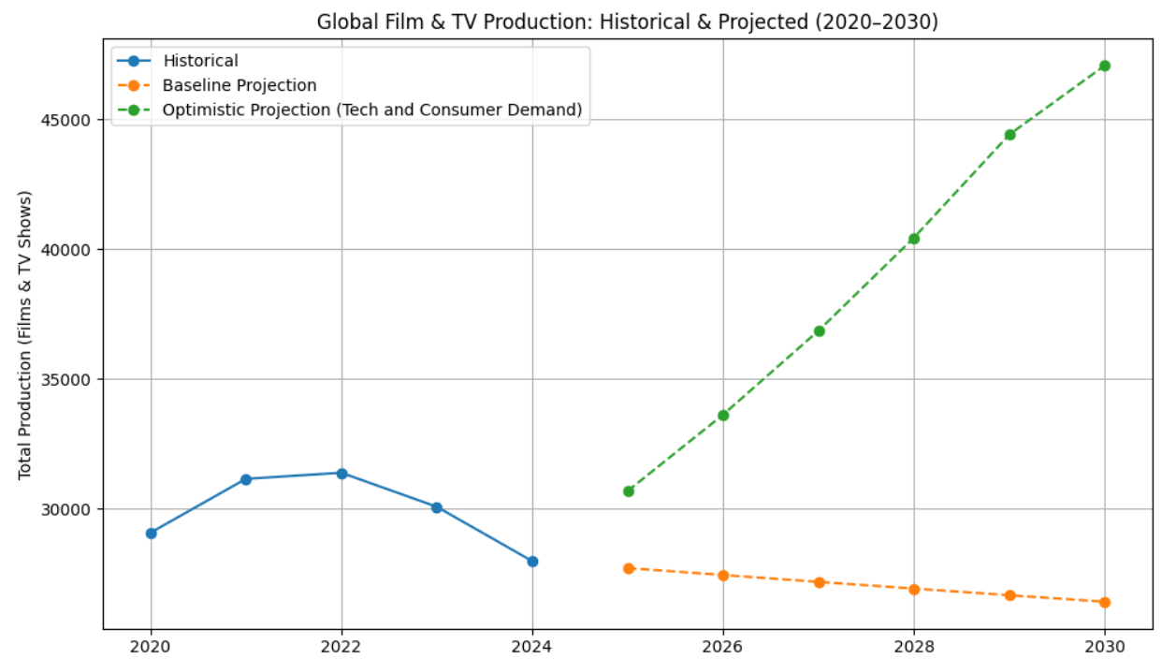

This chart is created using Python as shown [here](https://colab.research.google.com/drive/1Llu1G90IShxc4F_blXCtqEpBdC4hiad8#scrollTo=AQtV-qnlxf-8)

**5. Percentage of global box office revenue generated by international markets in the next five years**

* This question requires predicting the contribution of non-domestic markets to the overall box office revenue, taking into account trends in international film distribution and audience preferences.

Answer :

Source = <https://en.wikipedia.org/wiki/Box_Office_Mojo> ,

|  |  |  |  |
| --- | --- | --- | --- |
| **Historical Data Overview**  **Box office revenue (In Billion USD)** | | | |
| **Year** | **Revenue** | **Domestic** | **Non-Domestic** |
| 2020 | 14.07 Billion | 1.95 billion (13%) | 12.12 billion (77%) |
| 2021 | 21.9 Billion | 4.48 billion (20%) | 17.42 billion (80%) |
| 2022 | 26.0 Billion | 7.37 billion (28%) | 18.63 billion (72%) |
| 2023 | 33.9 Billion | 8.9 billion (26%) | 25.00 billion (74%) |
| 2024 | 32.3 Billion (estimated) | 8.57 billion (26%) | 23.73 billion (74%) |

**CAGR Calculation (2020 to 2024) :**

Formula  =  (Final Value / Initial Value) ^ (1 / n) - 1

**Where :**

Initial Value (2020) = 14.07 billion

Final Value = (2024) = 32.3 billion

**Caculation :**

**CAGR** = (32.3 / 14.07) ^ (1/4) - 1

= 2.296^ 0.25 - 1

= 1.233 - 1

= 0.233 * 100 = 23.3%

**Future Global Revenue Forecast(2025 - 2029):**

**Formula**

Revenue n  = Base Revenue  x (1+CAGR)^n

Where n = numbers of years after 2024

**Non Domestic Revenue Estimation Based On Previous Study :**

Calculating avg of non domestic revenue percentage  =

(86.1 + 79.6 + 71.6 + 73.7 + 73.5) / 5 = 76.9 %

We can take 70 % as a guess estimation for this because of following

It’s slightly lower than recent trend, offering margin of safety

Accounts for possible decline in international dominance (due to regional streaming growth, localization, etc.)

Keeps forecasting conservative and realistic.

|  |  |  |  |
| --- | --- | --- | --- |
| **Forecasted Revenue Of Next 5 Years(2025 - 2029)** | |  |  |
| **Years** | **Formula Implementation** | **Forecasted Revenue** | **Non-Domestic (70%)** |
| 2025 | 32.3 × (1 + 0.233)^1 | 39.81 billion | 27.87 billion |
| 2026 | 32.3 × (1 + 0.233)^2 | 49.08 billion | 34.36 billon |
| 2027 | 32.3 × (1 + 0.233)^3 | 60.48 billion | 42.34 billion |
| 2028 | 32.3 × (1 + 0.233)^4 | 74.48 billion | 52.13 billion |
| 2029 | 32.3 × (1 + 0.233)^5 | 91.68 billion | 64.18 billion |

Based on recent trends and a conservative estimate of 70% international contribution, this analysis projects the non-domestic box office revenue for the next five years using CAGR. The results offer a realistic outlook for global market performance and can guide strategic planning in the film industry.

**Part - III**

**Scenario 1 :** An entertainment company wants to analyse the behaviour of users who signed up for a **premium streaming subscription** in the past year. They want to track how many of these users renew their subscription in the months following their initial sign-up.

**Question 1**:  
How would you calculate the **monthly retention rate** for each cohort of users who signed up in different months?

* **Hint**: Group users by the month they signed up (cohort), and calculate the percentage of users who renew their subscription in subsequent months.

**Question 2**:  
If you notice that users tend to drop off after the third month, what strategies would you propose to improve **long-term retention**?

* **Hint**: Consider offering special discounts, exclusive content, or personalised recommendations to keep users engaged after the initial months.

**Solution 1 :**

To calculate the monthly retention rate for each user cohort:

1. Define Cohorts: Group users by their signup_month (the month they initially subscribed).
2. Calculate Initial Cohort Size: For each signup_month cohort, count the total number of unique users.
3. Track Active Users Per Month: For each signup_month cohort, and for each subsequent month (Month 1, Month 2, etc., relative to signup):
   * Identify the actual calendar month (e.g., if signup was Jan 2024, Month 3 is Apr 2024).
   * Count how many users from that *original cohort* were still actively subscribed (i.e., their subscription covered that specific calendar month).
4. Calculate Retention Rate: Divide the number of active users in each subsequent month by the initial cohort size, then multiply by 100 to get a percentage.

### Cohort Analysis Metrics Table – Netflix Subscription Retention

|  |  |  |  |
| --- | --- | --- | --- |
| **Step** | **Details** | **Metric** | **Details** |
| **Define Cohorts** | Group users based on the month they started their **first Netflix subscription**. | Subscription Start Month | E.g., Jan 2024 cohort includes all users who subscribed in January 2024. |
| **Track Metrics** | Monitor key metrics like renewal rate, watch activity, and churn over time. | Monthly Renewal Rate | Percentage of users in each cohort who renew their subscription each month. |
| Average Watch Time | Average number of hours watched per user in each cohort per month. |
| **Analyze Data** | Compare how different cohorts behave across months to spot trends. | Retention Rate | % of original cohort still subscribed after 1, 3, 6 months. |
| Engagement Rate | % of users who streamed at least 1 title per month. |

### Step 1: Data Collection

|  |  |  |  |  |
| --- | --- | --- | --- | --- |
| **User ID** | **Subscription Start** | **Subscription End** | **Activity Month** | **Watch Hours** |
| 1 | 2024-01-05 | 2024-04-05 | 2024-01 | 30 |
| 1 | 2024-01-05 | 2024-04-05 | 2024-02 | 40 |
| 1 | 2024-01-05 | 2024-04-05 | 2024-03 | 50 |
| 2 | 2024-01-18 | 2024-03-18 | 2024-01 | 20 |
| 2 | 2024-01-18 | 2024-03-18 | 2024-02 | 60 |
| 3 | 2024-02-10 | 2024-04-10 | 2024-02 | 35 |
| 3 | 2024-02-10 | 2024-04-10 | 2024-03 | 25 |
| 4 | 2024-02-15 | 2024-03-15 | 2024-02 | 15 |
| 5 | 2024-03-05 | 2024-05-05 | 2024-03 | 45 |
| 5 | 2024-03-05 | 2024-05-05 | 2024-04 | 50 |

### Step 2: Define Cohorts

|  |  |  |  |
| --- | --- | --- | --- |
| **Cohort** | **User IDs** | **Cohort Start Date** | **Cohort End Date** |
| Jan 2024 | 1, 2 | 2024-01-01 | 2024-01-31 |
| Feb 2024 | 3, 4 | 2024-02-01 | 2024-02-28 |
| Mar 2024 | 5 | 2024-03-01 | 2024-03-31 |

### Step 3: Track Metrics

|  |  |  |  |
| --- | --- | --- | --- |
| **Metric** | **Jan 2024 Cohort** | **Feb 2024 Cohort** | **Mar 2024 Cohort** |
| Number of Users | 2 | 2 | 1 |
| Initial Watch Hours | 30, 20 | 35, 15 | 45 |
| Repeat Activity Months | 2 | 1 | 1 |
| Total Watch Hours | 120 | 75 | 95 |
| Retention After 1 Month | 100% (2/2) | 50% (1/2) | 100% (1/1) |

### Step 4: Analyse Patterns

|  |  |  |  |
| --- | --- | --- | --- |
| **Pattern** | **Jan 2024 Cohort** | **Feb 2024 Cohort** | **Mar 2024 Cohort** |
| Avg Initial Watch Hours | 25 | 25 | 45 |
| Avg Total Watch Hours/User | 60 | 37.5 | 95 |
| Retention After 2nd Month | 50% | 0% | — |
| Engagement Trend | Increasing | Declining | Consistent |

[**Colab link for The Entire Analysis of The Data**](https://colab.research.google.com/drive/1nu0FLSzcPGmQ9eX00348YDPDs5YWfLn2?usp=sharing)

**HeatMap Showing Monthly Retention**

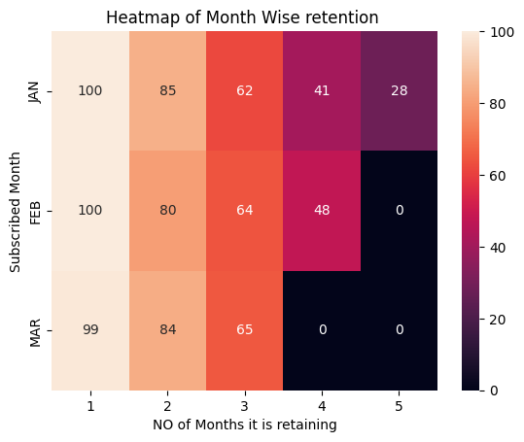

**Boxplot Showing How Watch Hours Can affect the Retention Status**

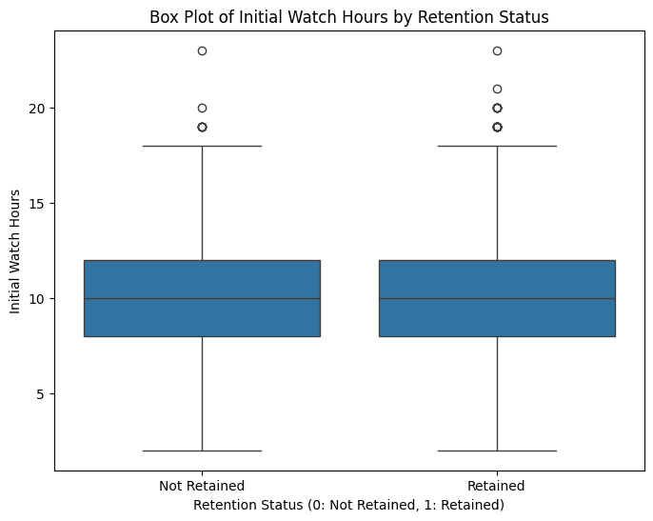

**Violin Plot of Average Watch Hours by no of months a user is Subscribed**

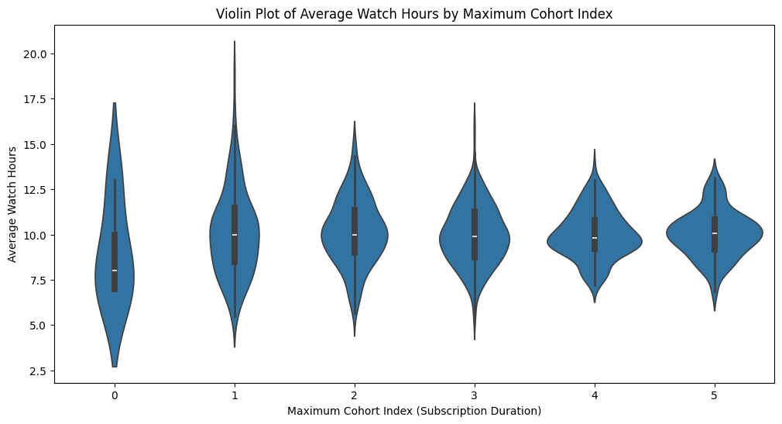

**Step 5 : Actionable Insights**

|  |  |
| --- | --- |
| **Insights** | **Actions** |
| **Retention decreases over time:** The retention heatmap shows a decline in retention rate as the cohort index increases. | Implement strategies to re-engage users in later months, such as personalized content recommendations or targeted promotions. |
| **Watch hours vary by subscription duration:** The box and violin plots suggest a relationship between how long a user subscribes and their average watch hours. | Analyze the watch patterns of long-term subscribers to identify common characteristics and tailor content or features to encourage similar behavior in newer users. |
| **Initial watch hours may influence retention:** The box plot comparing initial watch hours for retained and not-retained users shows a potential difference. | Investigate if higher initial watch hours correlate with increased retention and consider onboarding strategies that encourage early engagement. |

**Solution 2 :**

**After the analysis if we look at the heatmap of the retention rates it’s clearly saying that the retention rates drops after the third month . so Here are some proposed strategies to improve long term retention.**

|  |  |  |
| --- | --- | --- |
| **Category** | **Strategy** | **Description** |
| **Content Engagement** | **Personalized Recommendations** | Leverage AI to suggest highly relevant content based on individual viewing history and preferences. |
| **Exclusive/Early Access Content** | Offer unique shows, behind-the-scenes content, or early access to new releases for long-term subscribers. |
| **Consistent Content Pipeline** | Ensure a steady stream of new and engaging original content to prevent boredom. |
| **User Experience & Value** | **Targeted Re-engagement Offers** | Provide personalized discounts or promotions around the 2-3 month mark to at-risk users. |
| **Highlight Value Reinforcement** | Periodically communicate new features, added content, or viewing milestones to remind users of subscription benefits. |
| **Seamless Multi-Device Experience** | Ensure consistent, high-quality streaming and user experience across all devices. |
| **Community & Interaction** | **Gamification & Rewards** | Implement badges or loyalty points for continuous subscription or engagement (e.g., "6-Month Streamer"). |
| **Community Features** | Foster user interaction through forums, watch parties, or polls related to content. |
| **Proactive Support** | **Automated Nudge Campaigns** | Send personalized in-app notifications or emails prompting users to explore new content or features. |
| **Solicit & Act on Feedback** | Proactively gather feedback from users, especially around the 2-3 month mark, to address pain points. |

#### Scenario 2:

A gaming company is testing two different **tutorial designs** for new users in its mobile game. **Version A** is a brief, text-based tutorial, while **Version B** is an interactive, step-by-step guide. They want to see which tutorial leads to better **user retention** and higher **conversion rates** (i.e., users making in-game purchases).

**Question 1**:  
Design an **A/B test** to evaluate which tutorial version leads to better retention and conversion rates. What metrics would you use to measure success?

* **Hint**: Track retention (e.g., percentage of users who return after one week) and conversion rates (e.g., percentage of users who make their first purchase within 7 days).

**Question 2**:  
If **Version B** (interactive guide) shows higher conversion rates but slightly lower retention, how would you balance these results when making a recommendation to the business?

* **Hint**: Consider the long-term value of higher conversions versus the potential impact of reduced retention. You might suggest refining Version B to improve retention without sacrificing conversions.

**Solution 1 :**

**Hypothesis:**

***“Users who go through an interactive, step-by-step tutorial (Version B) will have higher retention and conversion rates than those who go through a text-based tutorial (Version A).”***

**A/B Test Design :**

**Variants :**

Variant A (Control): Text-based tutorial

Variant B (Treatment): Interactive tutorial

**Selection :**

To ensure that their is no selection bias we have decided to assign random assignment with 50% to user A and 50% to user B .

#### Duration

Run the experiment for **14 days**, tracking user behavior for 7 days after onboarding.

#### d. Isolation

Ensure users in each group are isolated from other influences like promotions, ads, or referral bonuses.